Database Notes

Section 36 – MongoDB Intro
- 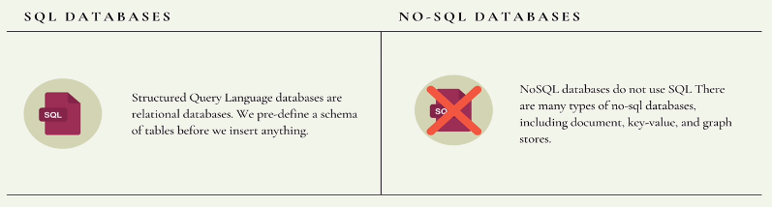
  - It is a no-sql Database

Start the Mongo Shell
- 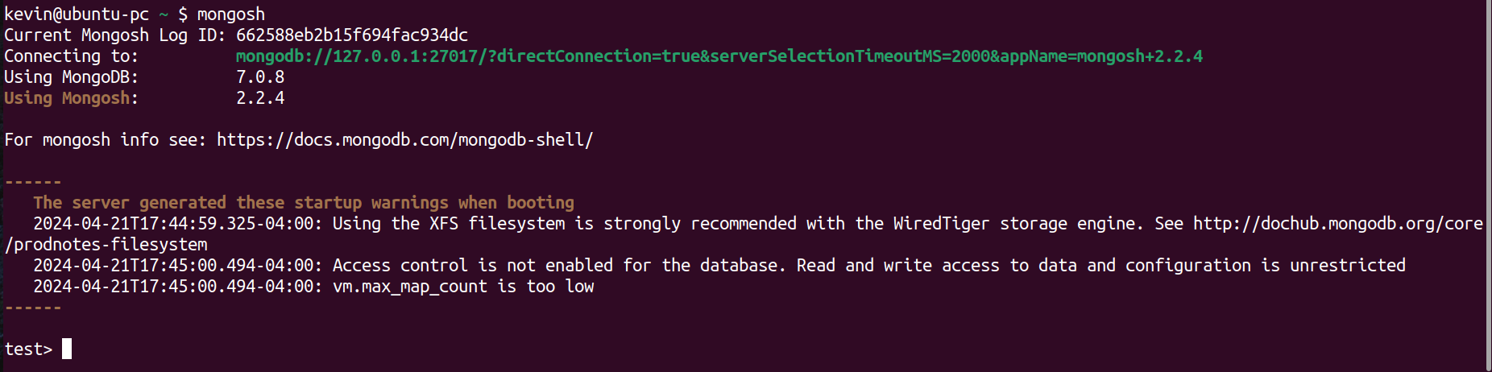
- Starter Commands:
  - mongosh = start mongodb instance
  - sudo systemctl status mongod = check status of mongodb instance
  - sudo systemctl restart mongod
  - sudo systemctl start mongod
  - sudo systemctl stop mongod
- This shell runs in JavaScript
- Create a new DB with command:
  - use <db name>

What is BSON?
- This is Binary JSON which is stored in Mongo’s Dbs. Though you first write in JSON, it gets converted by MongoDB

MongoDB Shell – CRUD Operations

1) Inserting (C)
- You insert data into ‘collections’
- 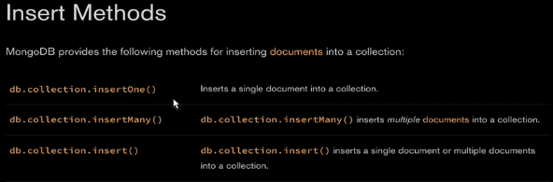
  - Replace <collection> with name of collection
    - ex. db.dogs.insert()
      - 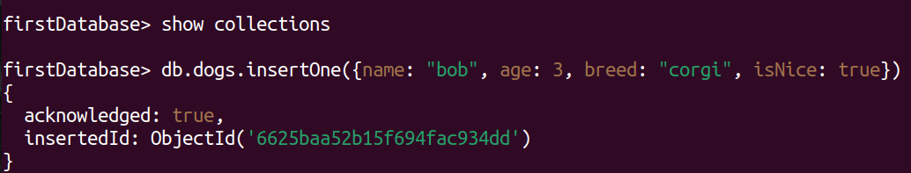
      - 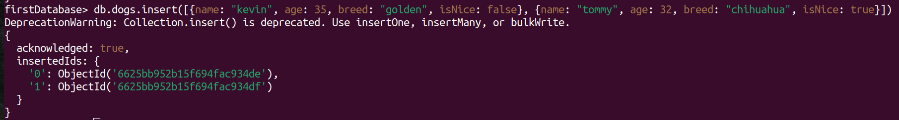
        - .insert() is depreciated, so use ‘.insertMany()’

2) Finding/Reading (R)
- db.<collection>.find()
  - Returns every item (aka ‘document’) in collection
    - SPECIFICALLY: returns the ‘cursor’/reference of the document
  - Ex. Find all documents with breed: ‘corgi’
    - 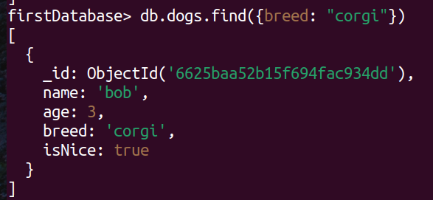

3) Updating (U)
- Commands:
  - 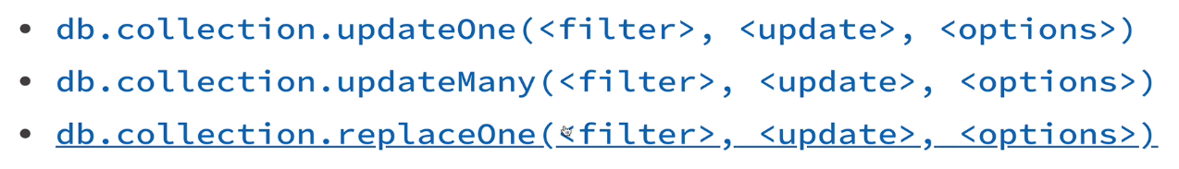
- use the $set operator to replace a field’s original value
  - Ex. 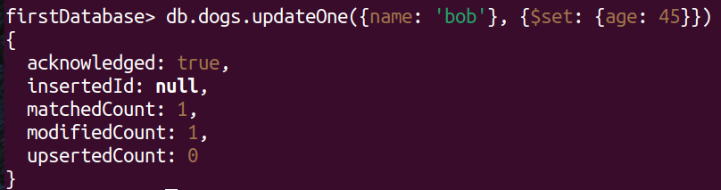
  - It can also ADD new fields to an item/doc

4) Deleting (D)
- Commands:
  - 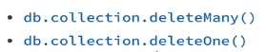
- Ex.
  - 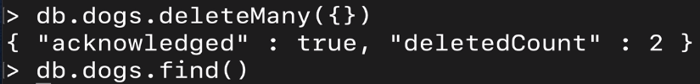

Additional Operators
- Accessing properties that are nested
  - db.dog.find({‘personality.childFriendly’: true})
- Size Operators:
  - $gt = greater than
    - db.dogs.find({age: {$gt: 50}})
  - $gte = greater than, equal
  - $in = contains

Section 37 – MongooseJS: Connect JS to MongoDB
- Doc: https://mongoosejs.com/
  - Used to connect Express Web App to MongoDB
  - It is an ODM (object data/document mapper)
    - 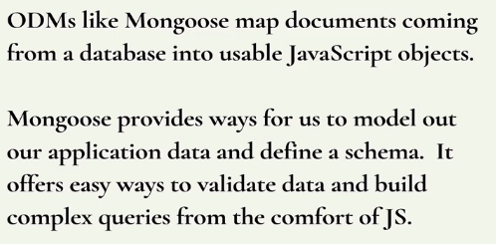
    - Used for CRUD operations!
      - You can add specific functions
- Connecting to MongoDB with MongooseJS
  - 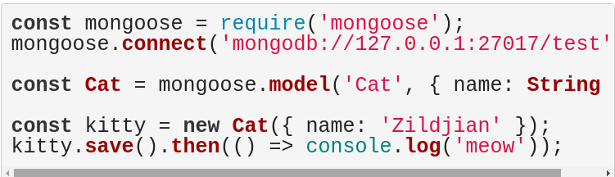

Mongoose Models
- They are JS classes which rep data in a mongodb’s collection
- Models are used with SCHEMA which maps to a MongoDB collection
  - They define the shape of the documents within that collection.
  - 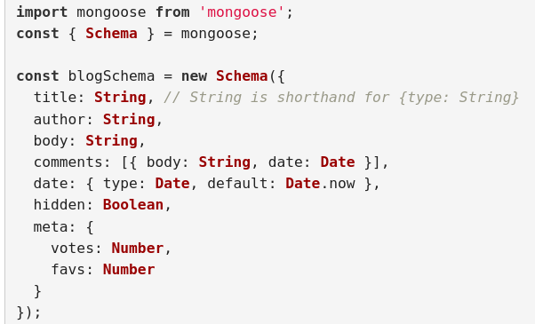 - Each key/prop needs a data type (value)
  - Then you take that SCHEMA and use it to compile a MODEL = new collection/table
    - Takes in a collection name + schema

Mongoose CRUD – using JS to interact with MongoDB

1) InsertMany() - Create
- This will chain in/insert to MongoDB right away without the use of .save()
- 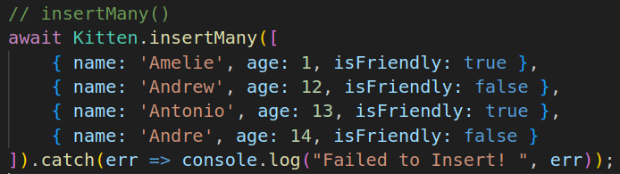

2) Finding Items in Collection(Model)
- Simplest query:
  - <Model Name>.find({}).then(data => console.log(data))
    - .find() produces a Querable Object
      - Mongoose queries are not promises.
      - Queries are thenables, meaning they have a .then() method for async/await as a convenience
- Others Queries:
  - .findOne()
    - Example:
      - await Adventure.findOne({ country: 'Croatia' });
  - .findById()
    - Example:
      - await Adventure.findById(id).exec();

3) Updating
- .UpdateOne() or .UpdateMany()
  - Example:
    - await <model>.updateOne({<query>}, {prop: new value}).then(msg => console.log(msg));
  - Example 2:
  - Both these examples will return a response stating that item was removed
- .findOneAndUpdate() or .findByIdAndUpdate()
  - 1) 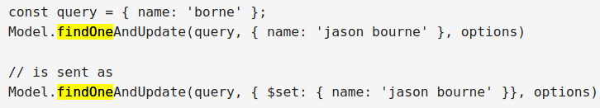
    - This returns the actual item before it was updated by DEFAULT!
      - But you can set the ‘options’ and set it to true -> ({new: true})
      - This produces the updated version
  - 2) 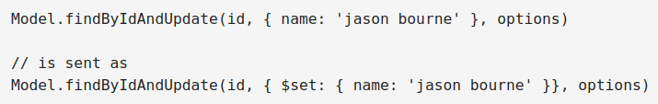

4) Deleting
- This command will delete from MongoDB right away!
- .deleteOne()
    - Only returns the operation
- .findOneAndDelete()
  - 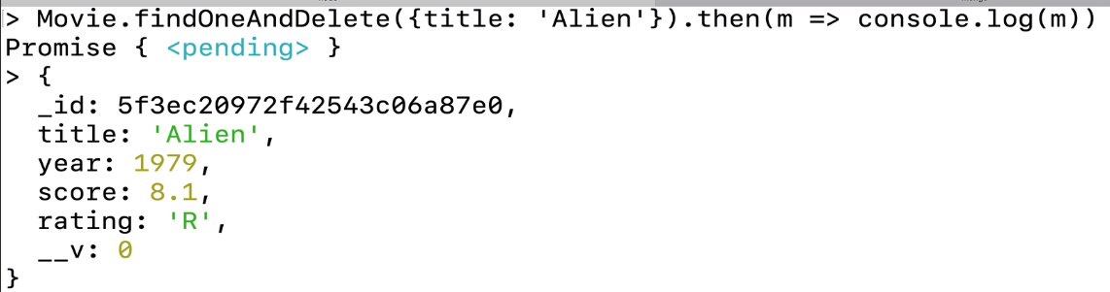
    - Returns a ‘Query’ for a document

Mongoose Schema Validation
- 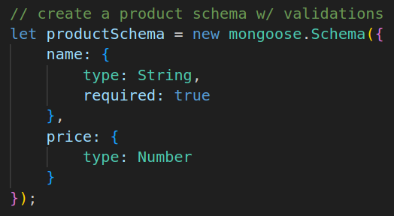
  - The ‘required’ field, enforces that a value be provided for that field
    - Enforces that a valid value be provided
    - Enforces that only 2 defined fields can be inputted

Additional Constraints
- You can attach constraints by var type for each field
  - String or Number:
    - 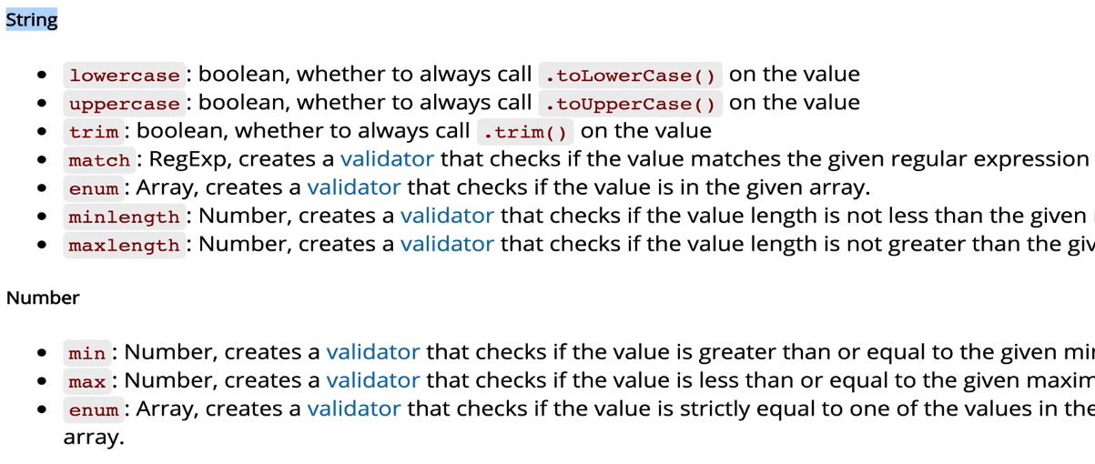

Validation for Updates to Documents
- Without setting the option, ‘updating’ will not follow the validators!
  - This option enforces validators!

Validation Error Msgs
- Error Msg for invalid value
  - 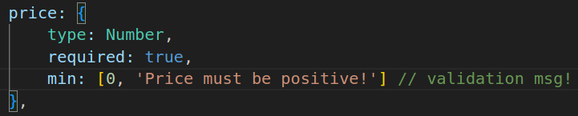
- Enforcing that specific values are entered

Mongoose Model Methods

1) Instance Method
- This adds custom functions to the Model’s documents
  - Simple Ex:
    - 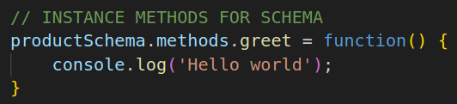
      - This adds a .greet() to ALL the instances created with the ‘productSchema’
  - Other Examples:
    - 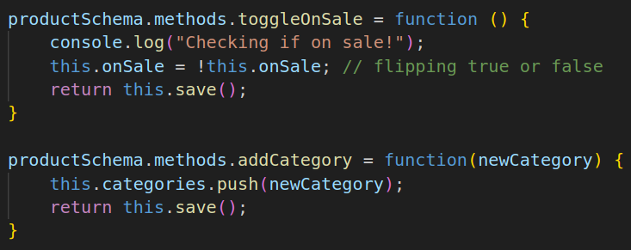

Static Methods
- Custom methods that are added to Model itself
- Examples:
  - 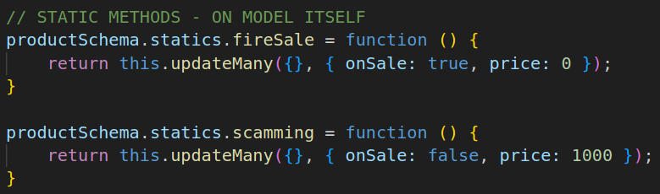

Comparison – Instance vs Static
- Instance method – refers to a single object in the db.
  - The keyword "this" in instance methods refers to a particular object in the database
- Static methods – refer to the whole model.
  - The keyword "this" refers to Product.

Mongoose Schema Virtuals
- Virtuals are document/item properties that you can get and set but that do not get persisted to MongoDB
- It is only on the MongooseJS side
  - Example:
    - 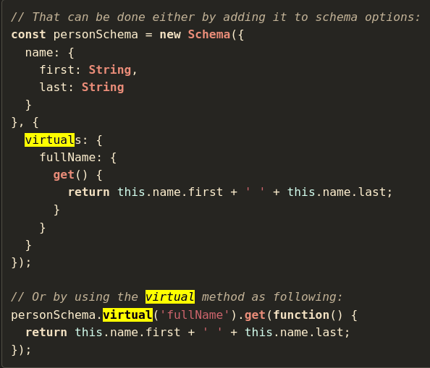
      - You can define the Virtuals props with the 2 ways (shown above)
        - 1) In the schema as an embedded virtual prop (w/ value produced by a method)
        - 2) As a property with the value of a get() method

Mongoose Middleware
- Middleware (pre/post hooks)
  - Are functions which are passed control during execution of asynchronous functions.
    - Middleware is specified on the schema level.
  - Example:
    - Pre-hooks → execute before .save()
    - Post-hooks → execute after .save())
    - 

